### **Report on Tools for Edge AI and IoT Development**

This report discusses various tools and technologies used in Edge AI and IoT development, focusing on their key features, purposes, and typical use cases. The tools examined include Visual Studio Code (VS Code), Node.js, Edge Impulse CLI, TensorFlow and TensorFlow Lite, Google Colab, and Generative AI Coding Tools.

### **a. Visual Studio Code (VS Code)**

#### **Description:**

Visual Studio Code (VS Code) is a free, open-source Integrated Development Environment (IDE) developed by Microsoft. It is designed for coding in multiple programming languages and provides various features that help developers write, debug, and deploy code efficiently. VS Code offers extensibility via plugins, built-in Git support, intelligent code completion, syntax highlighting, and debugging tools.

#### **Purpose:**

VS Code is popular for its lightweight and highly customizable nature. It supports a wide range of programming languages, making it suitable for different development environments, from simple scripts to large, complex applications. Its rich set of features, such as version control, task running, and debugging, enhances developer productivity, making it a preferred tool in Edge AI and IoT development.

#### **Typical Use Cases:**

* **Edge AI Development**: VS Code is widely used for developing AI applications that need to run at the edge. With extensions like Python, Jupyter, and TensorFlow, developers can easily write and test machine learning models in a localized development environment.
* **IoT Development**: In IoT, VS Code can be used to write code for embedded systems using C++, Python, and JavaScript. The platform allows easy integration with microcontroller boards (e.g., Raspberry Pi, Arduino) for deploying IoT applications.

**Illustrative Example**:  
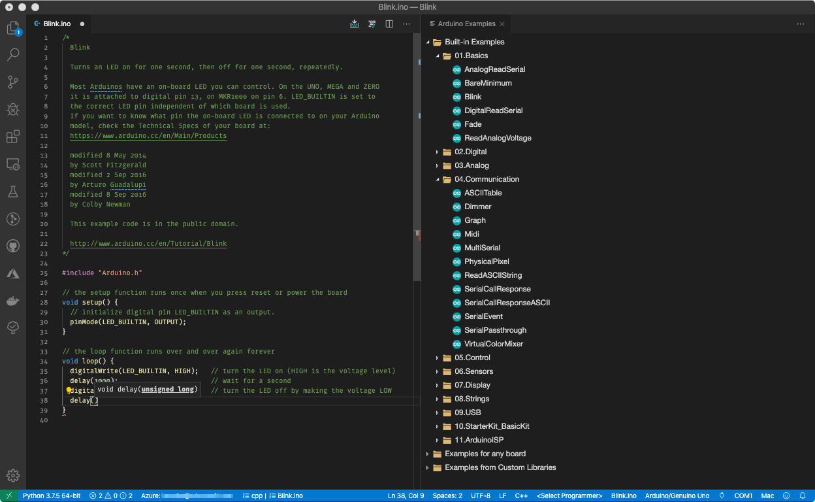

### **b. Node.js**

#### **Description:**

Node.js is a JavaScript runtime built on Chrome's V8 engine that enables developers to run JavaScript code server-side. It is event-driven and asynchronous, making it ideal for building scalable applications. Node.js uses non-blocking I/O, which allows for handling multiple concurrent connections efficiently, making it a great fit for real-time applications and web servers.

#### **Purpose:**

Node.js is designed to build fast, scalable network applications. It is particularly strong in handling real-time, data-intensive applications due to its event-driven architecture and lightweight nature. This makes it a favored choice for backend development in IoT applications, especially where real-time data processing and communication are essential.

#### **Typical Use Cases:**

* **Real-time IoT Applications**: Node.js is used to build communication servers that manage real-time data from IoT devices. For example, it can handle data streams from sensors and process them in real-time.
* **Edge AI**: Node.js can serve as the backend for edge AI systems, processing machine learning inference results from edge devices and sending the data to central servers or cloud services for further analysis.

**Illustrative Example**:  
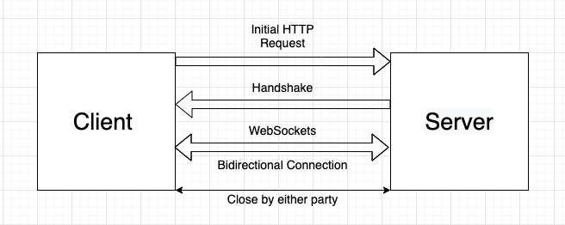

### **c. Edge Impulse CLI**

#### **Description:**

Edge Impulse CLI (Command Line Interface) is a tool used for developing and deploying machine learning models on edge devices. It allows developers to create machine learning models by collecting data from sensors, training models, and then deploying these models to edge devices directly from the terminal.

#### **Purpose:**

Edge Impulse CLI simplifies the process of creating machine learning models for edge AI. It supports the end-to-end development cycle of a model, from data collection to deployment on resource-constrained devices. This makes it an essential tool for developers working on AI-powered edge devices.

#### **Typical Use Cases:**

* **Edge AI**: Used for collecting data from edge sensors (e.g., accelerometers, cameras), training machine learning models on the collected data, and deploying the models to embedded devices like microcontrollers and embedded processors.
* **IoT Devices**: In IoT, it is often used for integrating AI capabilities into IoT devices that perform local data processing, such as anomaly detection in sensor data.

**Illustrative Example**:  
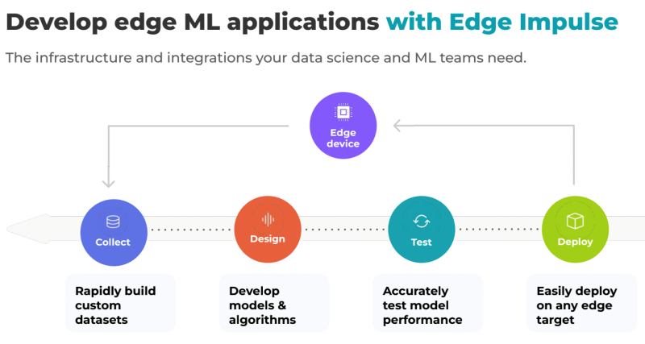

### **d. TensorFlow and TensorFlow Lite**

#### **Description:**

TensorFlow is an open-source machine learning library developed by Google, providing tools for building and training models in various domains such as image recognition, natural language processing, and time series analysis. TensorFlow Lite is a lightweight version of TensorFlow designed for mobile and embedded devices. TensorFlow Lite enables the deployment of machine learning models on resource-constrained devices.

#### **Purpose:**

TensorFlow serves as a powerful tool for developing machine learning models, while TensorFlow Lite allows the deployment of these models to edge devices, offering optimized performance on devices with limited resources (e.g., low power, memory, and CPU capabilities).

#### **Typical Use Cases:**

* **Edge AI**: TensorFlow Lite is commonly used to deploy machine learning models on edge devices, such as smartphones or IoT sensors, for tasks like image classification, speech recognition, and predictive maintenance.
* **IoT**: In IoT projects, TensorFlow Lite helps optimize models for devices with limited computational power, allowing machine learning inference to occur on the device rather than relying on cloud processing.

**Illustrative Example**:  
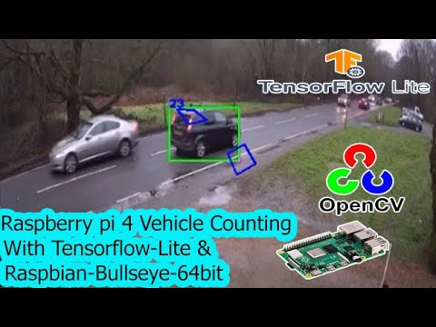

### **e. Google Colab**

#### **Description:**

Google Colab is a free cloud-based platform that provides Jupyter notebooks with access to computational resources like CPUs, GPUs, and TPUs. It is widely used for machine learning and data analysis tasks, offering an easy-to-use interface for running Python code without needing to set up a local environment.

#### **Purpose:**

Google Colab facilitates collaboration and cloud-based development, especially for machine learning projects. It is often used for training models, experimenting with new algorithms, and sharing work in a collaborative manner. Its access to powerful GPUs/TPUs makes it suitable for large-scale AI model training.

#### **Typical Use Cases:**

* **AI and IoT Development**: Google Colab is used for training and testing machine learning models on large datasets. It can also be used for collaborating on research projects, where multiple developers can work together in real-time.
* **Edge AI**: While primarily for model development, Colab can be used to build and optimize models that are later deployed on edge devices.

**Illustrative Example**:  
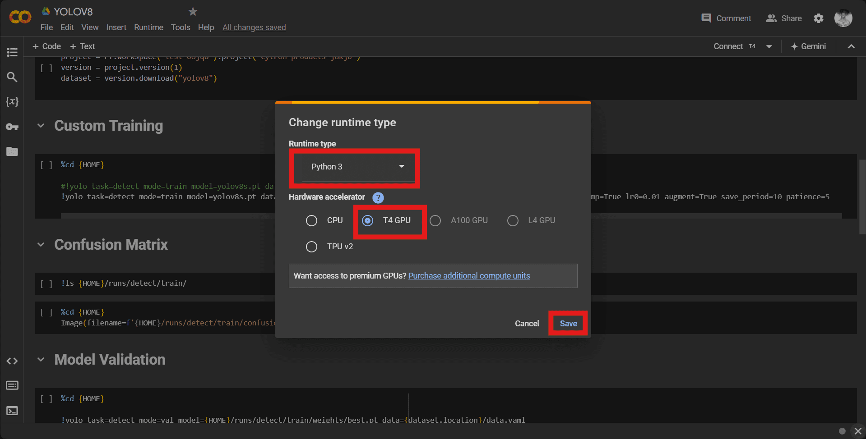

### **f. Generative AI Coding Tools (e.g., GitHub Copilot, OpenAI Codex)**

#### **Description:**

Generative AI coding tools like GitHub Copilot and OpenAI Codex are AI-powered assistants that help developers write code more efficiently. They generate code suggestions, complete functions, and assist with debugging by understanding context from the codebase.

#### **Purpose:**

These tools assist developers in writing and debugging code faster by providing intelligent suggestions, reducing the time spent on repetitive coding tasks, and improving the overall coding experience.

#### **Typical Use Cases:**

* **Edge AI**: Developers working on Edge AI projects use these tools to speed up the process of coding machine learning models, sensors, and other edge application components.
* **IoT**: In IoT, these tools are used to quickly generate code for data processing, sensor integration, and communication protocols, helping developers focus on application-specific logic.

**Illustrative Example**:  
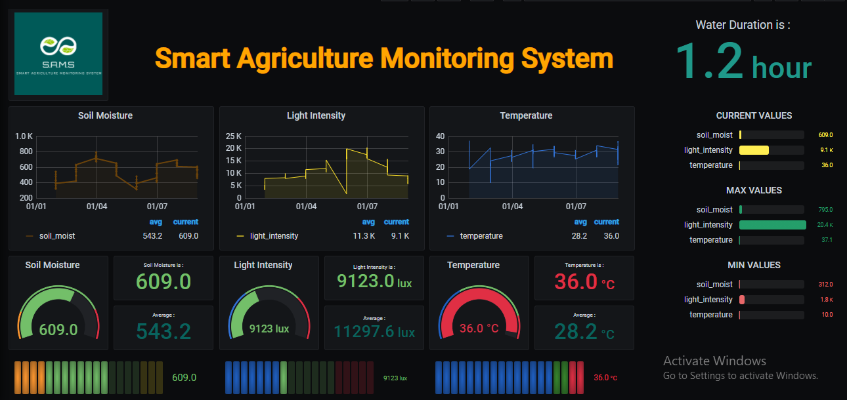

### **Conclusion**

Each of the tools discussed in this report plays a vital role in the development of Edge AI and IoT applications. From lightweight IDEs like VS Code to powerful machine learning frameworks like TensorFlow Lite, these tools make it easier for developers to build, deploy, and optimize AI-powered systems on resource-constrained devices. They provide essential functionalities, such as cloud-based development, real-time data processing, and machine learning model deployment, making them indispensable in the fast-evolving Edge AI and IoT landscape.

TensorFlow and PyTorch are two of the most popular deep learning frameworks, each with unique strengths that make them suitable for specific real-world applications. Here's a comparison of their applications across various domains:

TensorFlow

TensorFlow, developed by Google, is widely recognized for its scalability, production-ready features, and integration with other tools. Its real-world applications include:

1. Industry and Enterprise Applications:
   * Google Products: TensorFlow powers products like Google Translate, Photos, and Assistant due to its scalability and support for natural language processing (NLP) and image recognition.
   * Financial Services: TensorFlow is often used in fraud detection, risk assessment, and automated trading systems.
2. Healthcare:
   * TensorFlow models are deployed in medical imaging (e.g., MRI analysis, disease detection in X-rays).
   * It's used in genomics research for DNA sequence classification and drug discovery.
3. Autonomous Vehicles:
   * TensorFlow's ability to handle large datasets makes it ideal for training computer vision models for self-driving cars.
4. Reinforcement Learning:
   * TensorFlow-Agents, an extension for reinforcement learning, is used in gaming and robotics.
5. Edge and Mobile Applications:
   * TensorFlow Lite facilitates deploying models on mobile and IoT devices, enabling real-time image recognition and voice processing.

PyTorch

PyTorch, developed by Facebook, is renowned for its dynamic computation graph, user-friendly syntax, and flexibility. It is preferred in research and increasingly in production. Its real-world applications include:

1. Academia and Research:
   * PyTorch dominates research due to its ease of experimentation, widely used in computer vision, NLP, and generative models (e.g., GANs).
   * Facebook AI uses PyTorch for cutting-edge research in transformers and large language models (e.g., GPT, BERT).
2. Natural Language Processing (NLP):
   * PyTorch powers platforms like Hugging Face Transformers, enabling applications in machine translation, sentiment analysis, and chatbot development.
3. Autonomous Systems:
   * PyTorch is used for dynamic reinforcement learning tasks and robotics, where adaptability is crucial.
4. Media and Entertainment:
   * Companies use PyTorch for real-time facial recognition, animation rendering, and recommendation systems.
5. Healthcare and Biology:
   * PyTorch Lightning simplifies workflows for bioinformatics and protein structure prediction (e.g., AlphaFold-like applications).
6. Startups and Prototyping:
   * Due to its intuitive design, startups use PyTorch to quickly prototype AI models for innovative solutions like personalized medicine, e-commerce recommendations, and AR/VR technologies.

Comparative Insights

* TensorFlow excels in large-scale deployment, enterprise solutions, and edge device integration.
* PyTorch is preferred for rapid prototyping, academic research, and applications requiring flexible experimentation.

Both frameworks are widely used across industries and often adopted together, with TensorFlow leading in production environments and PyTorch being a favorite in research and development.